**Bayes Vs. EWMA**

**A Portfolio Optimization Game**

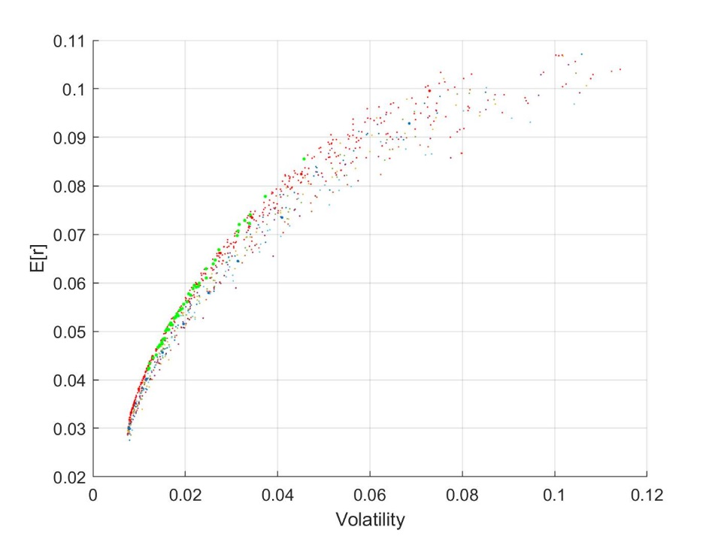

Harrison McKenny

**Table of Contents**

1). - Preface

2). - Introduction

3). - Investment Game Details

4). - Difference Between Optimization Strategies

5). - Results

6). - Conclusion

7). - Works Cited

8). - Appendix

**1). – Preface**

The recent rise of mobile trading applications has made investing in both equity and bond markets more accessible than ever. At the forefront of these mobile trading platforms rise to prominence, are millennial-aged investors. Popular mobile investment apps Robinhood and Acorns both reported an average user age of 32 this year, and Stash reported having an average user age of 29 (Kim). Millennial investors have largely ditched traditional trading behavior, such as buying index or other mutual funds and holding on to them as long term investments. The ease of utilizing mobile platforms for equities trading has seemingly bolstered younger investor’s propensity to partake in short-term trading (Rooney).

In an effort to give younger investors a fighting chance, this paper delves deep into optimal portfolio weighting for one period ahead trading. The methodology of our analysis focuses on determining optimal weights for the minimum variance portfolio. An exceedingly risk averse individual was the center of interest for this analysis, as millennial-aged investors are the most risk averse generation since The Great Depression (Markowitz). A group of six equity indices and two bond indices were selected for use in this analysis. The equity indices are for the United States, Canada, France, Germany, the United Kingdom and Japan. The bond indices are the United States Treasury Bond and a Eurodollar Bond. Therefore, we are using low risk equities that would be attractive to a risk averse individual and implementing an investing phenomenon that is becoming common place among millennial-aged investors.

**2). - Introduction**

This paper will investigate the use of Bayes vs Exponential Weighting Moving Average (EWMA) techniques in determining optimal portfolio weights to maximize return. This investment game is inspired by the work of Harvey et al. (2008) which compared the portfolio performance of two players, one using Bayesian methods for determining portfolio weights, while the other using Monte Carlo methods. The most significant difference between the investment game this paper outlines and the one executed by Harvey et al. is that the players in this game estimate the weights of the minimum variance portfolio. Thus, assuming the players are risk averse to the point that they prefer an investment portfolio with the least amount of risk possible. In other words, Harvey et al. have the players determine weights subject to varying risk tolerance parameters, while we focus on only the most risk averse investor.

The work of Harvey et al. shows that the Bayes player overwhelmingly outperforms the Monte Carlo player, subject to differing risk tolerance parameters. The more risk averse the investor is assumed to be, the better the Bayes player performs relative to the Monte Carlo player. We find that the Bayes player outperforms the EWMA player, however by a smaller margin.

**3). - An Investment Game**

Following Harvey, Liechty and Liechty (2008) we conduct a simulated investment game with two players and a referee. The assets under examination are a group of six equity indices and two bond indices. The equity indices are for the United States, Canada, France, Germany, the United Kingdom and Japan. The bond indices are the United States Treasury bond and a Eurodollar bond. Ten true parameter sets for a multivariate normal density are generated by the referee. Each set is a summary of asset returns for all eight of the indices we are looking at. In our game, we assume that these ten sets of indices are i.i.d. normal with means, variances and covariance given by the matrix that corresponds to the respective set of indices.

The data on returns of the eight assets comes from each individual assets’ monthly percent returns over 216 months from January 1978 to December 1995. The game is started with the Maximum Likelihood Estimates (MLE) of the mean and covariance for the collection of indices monthly returns. From which a vector of mean values and a covariance matrix is composed. The referee then generates 10 sets of parameters by generating 216 draws from a multivariate normal density using these parameters (vector of means and covariance matrix) and a new random seed; the true parameters are the MLE estimates from each corresponding sets of draws. Using each of the 10 truths, the referee then generates 100 histories (each with 216 simulated observations), which form the data used in the game. This is the same methodology used in Harvey et al. (2008) from which, we have a graphical representation to ease the explanation, depicted in figure 1.

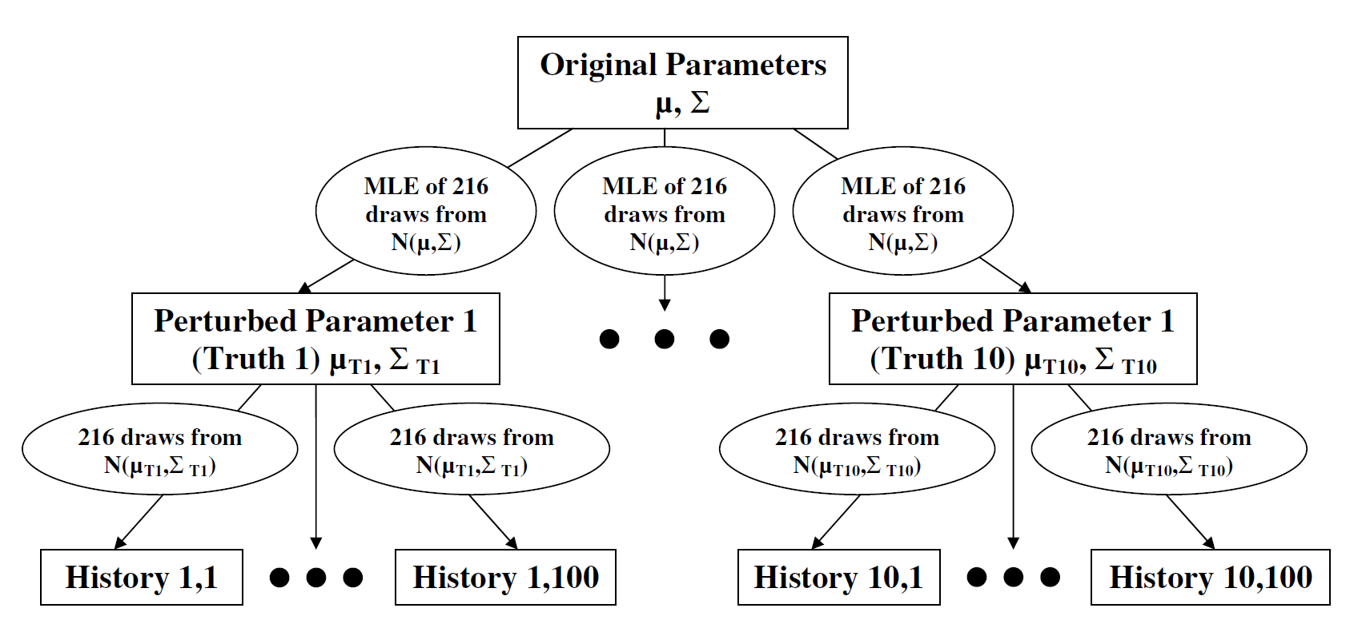

Figure 1: Graphical representation of simulated histories and truths

Where $ϻ and ∑$ are the mean and covariance matrix of the original parameters.

For each of these respective 100 histories from each of these respective 10 sets, the Bayesian and EWMA players use their respective methods to calculate portfolio weights. The portfolio weight values are applied to a 217th observation which is generated by the referee using the mean and the variance-covariance matrix of the 216 observations in each history. The referee then compares each players’ weights by calculating the players’ return by applying them to the returns in the 217th period; the player who achieves a higher expected return is considered the winner.

Where Harvey maximizes expected utility in his game, we proxy for higher expected utility by using highest return value (between EWMA and Bayes player) with the least amount of risk in the 217th observation of each history for each set. For each of the 100 histories, the player with the weights that result in a higher expected utility, using the true parameter values, is determined to have won.

In this project, we utilized a one period ahead asset allocation setting, as it is more relevant to an investor with a shorter investment horizon. The referee assumes that the investor will only hold the portfolio for one period and that the referee draws returns that are consistent with the history that has been presented to the player. As in Harvey et al. (2008) the referee draws 100 asset returns for the 217th period and applies the generated weights for both the EWMA and Bayes player to the data for the 217th period. To be mathematically clear, the asset returns for the 217th period are calculated by the referee from the predictive distributions as follows:

$$AssetReturns_{217}\sim N(ϻ|HistAssetReturns, ∑|HistAssetReturns)$$

and the returns for each player are calculated as follows:

$$Return_{bayes}=Weights_{bayes} x AssetReturns_{217}$$

$$Returns_{EWMA}=Weights_{EWMA} x AssetReturns_{217}$$

Equations 1 & 2

whichever return is larger is assumed to bring a higher expected utility and thus, wins the game.

**4). - EWMA vs. Bayes Optimization**

The EWMA and Bayes strategies for obtaining weights vary in two ways. First, they vary by the method used to calculate the covariances between the different assets. The EWMA model estimates the covariance matrix by finding the cross product between the different asset returns. This is standard except that the most recent asset returns are weighted heavier by the decay constant. This allows for more extreme returns to be discounted as they move further from the current period. The Bayesian approach to calculating the covariance relies on two separate measures of uncertainty:

1. The posterior mean of the historical covariances of the asset returns
2. The posterior mean of the covariance of the true mean returns of the assets.

The second component of the Bayesian calculation of the covariance incorporates the uncertainty created by the difference between the true mean returns of the assets and the observed returns of the assets. The second way the EWMA and Bayes strategies differ is in the way they calculate the means of the distribution. The EWMA estimates the sample mean by computing the moving average of the returns over a designated time frame. This differs from the Bayes method which uses a predictive mean which equals the posterior mean. The posterior mean is commonly estimated using by MLE of the mean of the historical returns of the assets. While the EWMA and Bayes strategies compute the means and covariance matrix of asset returns differently, they both use the same method to calculate the weights from the means and covariance matrix. From the means and covariance matrix an efficient frontier is crafted using the historical data. Next, the weights are computed to create a bundle with the minimal amount of risk on the efficient frontier. This is called the minimum variance portfolio.

**5). - Results**

Harvey’s investment game involves the players estimating optimal portfolio weights subject to different risk tolerance parameters. In this investment game, we assume the players are as risk averse as possible, thus they would only be content with purchasing the minimum variance portfolio. Basically, the game will determine which player is able to more accurately estimate the weights necessary to obtain the minimum variance portfolio in the 217th period, while securing the highest expected returns.

The Bayes player performs better in six out of ten rounds of the game. It is worth noting that the differences in observed returns in the 217th period for each player are fairly similar on average. The Bayes player slightly outperforms the EWMA player, realizing higher returns in the 217th period while taking on the least amount of risk.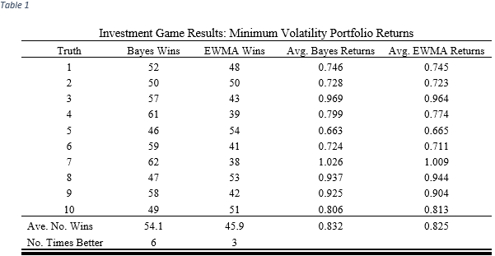

These results differ from Harvey et al. in that they showed that the Bayes player was able to estimate weights that resulted in higher expected utility in the 217th period for each round of the game. While our results differ in the number of rounds won, they are similar in that the more risk averse we assume the investor to be, the more the Bayes player outperform the other. This is an important implication of the results, and suggests that Bayesian optimization should be preferred by the more risk averse investor.

**6). - Conclusion**

Our analysis was conducted by playing an investment game which compared Bayesian strategies of portfolio optimization to EWMA strategies. In order to make this analysis relevant to younger investors that utilize mobile trading apps as their primary investment platform, we observe how well the players do in determining optimal weights for a one period ahead investment. It is important to reiterate that this game focusses on determining optimal weights for the minimum variance portfolio, as millennial-aged investors are the most risk averse generation since The Great Depression (Markowitz). The results of our analysis showed that the Bayes player outperformed the EWMA player, securing a higher return in the one-step ahead portfolio allocation six out of the ten rounds of the game. In one period there was a tie between the two players, leaving the EWMA player with just three wins out of ten rounds. Thus, we can conclude that Bayesian methods for portfolio allocation, relative to EWMA, are preferred for the risk averse investor. Moving forward, we recommend that an individual who is investing with a short time horizon utilize Bayesian methods when weighting their investment portfolio.

**7). - Works Cited**

Jorion, Philippe. (1986) Bayes-Stein Estimation for Portfolio Analysis. *Journal of Financial and*

*Quantitative Analysis,* 21(3), 279-292.

Kim, Crystal. “Tap and Trade: Apps Target Young Investors” *Barron’s,* 9 December 2017,

https://www.barrons.com/articles/tap-and-trade-apps-target-young-investors-1512789849.

Liechty, John and Harvey, Campbell R. and Liechty, Merrill W., Bayes vs. Resampling: A

Rematch (2008). *Journal of Investment Management*, Vol. 6 No. 1, First Quarter 2008.

Markowitz, H.M. and Usmen, N. (2003). “Resampled Frontiers Versus Diffuse Bayes: An

Experiment.” *Journal of* *Investment Management* **1**(4), 9–25

Michaud, R.O. (1998). *Efficient Asset Management*. Boston: Harvard Business School Press.

Moskowitz, Dan. “Are Millennials Risk Averse or Risk Takers?” *Investopedia,* 25 June 2019,

https://www.investopedia.com/articles/investing/070815/are-millennials-risk-averse-or-risk-

takers.asp.

RiskMetrics (1996) RiskMetrics Technical Document. J. P. Morgan/Reuters

Rooney, Kate. “Stock Trading Is Back, But No One Is Charging For It, Thanks To Millennials” *CNBC*

*Finance,* 11 November 2019, https://www.cnbc.com/2019/11/11/stock-trading-is-back-but-no-

one-is-charging-thanks-to-millennials.html.

**8). - Appendix**

**Bayes-Stein**

*Mean Vector in Bayes-Stein Estimation:*

$$E\left[r\right]=\left(1-w\right)Y+w1Y_{0}$$

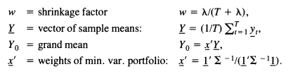

*Covariance matrix in Bayes-Stein Estimation:*

$V\left[r\right]=∑\left(1+\frac{1}{T+λ}\right)+\frac{λ}{T\left(T+1+λ\right)}\frac{{11}^{'}}{1^{'}\sum^{-1}{1}}$

Additionally, see Jorion (1986)

**EWMA**

*Covariance matrix in EWMA Estimation:*



Additionally, see RiskMetrics(1996)

*Mean vector in EWMA Estimation:*

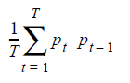

Additionally, see RiskMetrics(1996)